## Congratulations!

Congratulations! We've made it to the end of the course. Let's take a look at everything we've learned.

## 2. What you've learned

Our SQL vocabulary expanded by introducing the keywords COUNT and LIMIT in chapter one. We saw filtering techniques and IS NULL and IS NOT NULL in chapter two. We discussed ROUND and aggregate functions in chapter three, ORDER BY, DESC, GROUP BY, and HAVING in chapter four. We also covered comparison operators and arithmetic throughout.

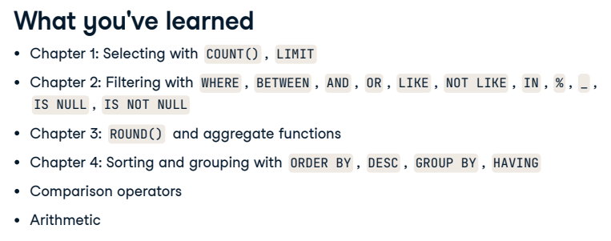

## 3. Skills

We now understand how to handle errors and missing values and how to debug and write clean, readable code. Our new SQL vocabulary of keywords means we are proficient in selecting, querying, filtering, summarizing, sorting, and grouping data. That's quite a lot; take a moment to celebrate this massive achievement!

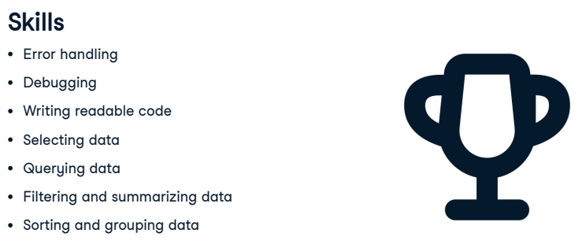

## 4. What's next?

Where to from here? You're ready for our joining course if you want to continue learning. Alternatively, DataCamp offers several practice options throughout the project, practice, and competitions pages. Or, head to Workspace and build a portfolio with your projects!

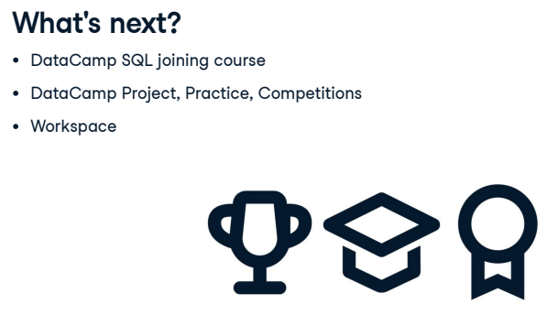

## 5. Congratulations!

Best of luck, and remember making mistakes is all part of learning!